1. Run setup file.

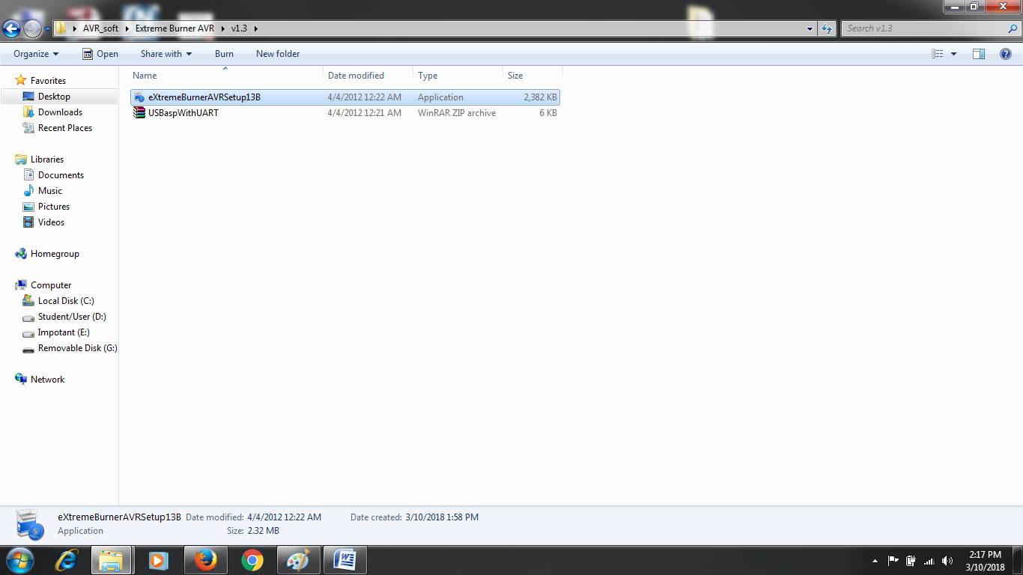

2.All steps select “NEXT” and “YES”, then Finish.